|  |
| --- |
| **油潤滑旋片式真空泵** |
| ***Oil Lubricated Rotary Vane*** |
| ***Vacuum Pump*** |
|  |
|  |
|  |
|  |
|  |
|  |
|  |

|  |
| --- |
| ***V0 Series*** |
|  |
|  |
|  |
|  |
|  |
|  |
|  |



|  |
| --- |
|  |

|  |
| --- |
| **VO - 20 / 25油潤滑旋片式真空泵 / Oil Lubricated Rotary Vane Vacuum Pump**  Oil lubricated rotary vane vacuum pump with capacities ranging from 20 to 26.5 m³/h and an ultimate vacuum of 2 mbar (abs.). Designed especially for installation in small vacuum packaging machines. Flange motor, bearings on both sides of the rotor, air cooling.  Fitted as standard with fine mesh filter, vacuum non-return valve and oil separator.  Flange mounted motors comply with DIN EN 60034, have IP54 protection and insulation class F. |

油潤滑旋片式真空泵，流量從20至26.5 m³/hr，絕對真空2mbar（絕對值）。特別是安裝在小型真空包裝機。法蘭式電機，轉子兩側裝有軸承及空氣冷卻，內置過濾篩網，真空逆止閥和油霧過濾器。

法蘭式電機符合DIN EN60034，具有IP54防護和絕緣等級F。

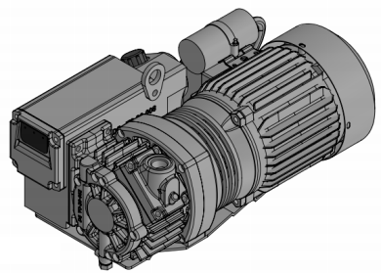

**性能曲線圖 / Performance Curve**

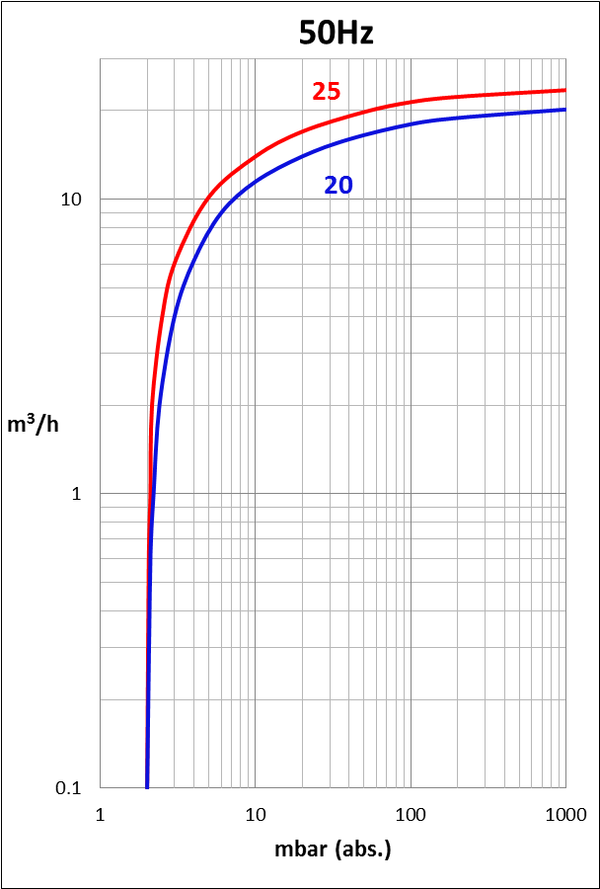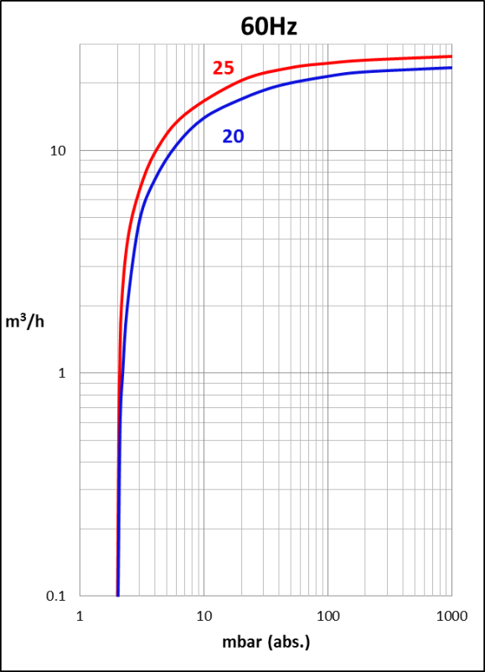

30

30

20

20

|  |  |  |  |  |  |  |
| --- | --- | --- | --- | --- | --- | --- |
| **VO** | | | **20** | | **25** | |
| **頻率Frequency** | Hz |  | **50 Hz** | **60 Hz** | **50 Hz** | **60 Hz** |
| **額定流量Nominal capacity** | m³/h |  | 20 | 24 | 22.5 | 26.5 |
| **絕對真空Ultimate partial pressure** | mbar (abs.) |  | 2 | | | |
| **電機類型Motor version** |  | 3~ | 50Hz - 200~240 / 346~415V / 60Hz - 220~275 / 380~480V | | | |
| 1~ | 230 V ± 10% | | | |
| **電機功率Motor rating** | kW | 3~ | 0.75 | 0.85 | 0.75 | 0.85 |
| 1~ | 0.75 | 0.85 | 0.75 | 0.85 |
| **電流Current** | A | 3~ | 3.70/2.14 | 3.90/2.25 | 3.70/2.14 | 3.90/2.25 |
| 1~ | 5.8 | 6.5 | 5.8 | 6.5 |
| **轉速Speed** | min¯¹ |  | 2830 | 3350 | 2830 | 3350 |
| **平均噪音值Average noise level** | dB(A) |  | 63 | 64 | 62 | 66 |
| **最大重量Maximum weight** | kg |  | 3~21.5 / 1~23 | | | |
| **油量Oil capacity** | I |  | 0.35 | | | |

|  |
| --- |
| **VO - 20 / 25油潤滑旋片式真空泵 / Oil Lubricated Rotary Vane Vacuum Pump** |

**尺寸圖 / Dimensions (mm)**



**我們保留調整數據的權利，尺寸和電流值會因不同的電機而與數據表不同。**

**We reserve the right to alter technical information. The dimensions and the current drawn can differ when compared with the data list, depending on the motor type.**

|  |  |  |  |
| --- | --- | --- | --- |
| **A** | **注油口Oil filling point** | **D** | **油霧分離器Oil separator** |
| **B** | **油位鏡Oil check** | **E** | **電容器（單相）Capacitor for 1 phase** |
| **C** | **排油口Oil drain point** |  |  |

|  |
| --- |
| **VO - 50 / 75油潤滑旋片式真空泵 / Oil Lubricated Rotary Vane Vacuum Pump** |

Oil lubricated rotary vane vacuum pump with capacities ranging from 50 to 84 m³/h and an ultimate vacuum of 0.1 mbar (abs.).

Flange motor, bearings on both sides of the rotor, air cooling. Fitted as standard with fine mesh filter, vacuum non-return valve, gas ballast valve, protection cover and oil separator.

Flange mounted motors comply with DIN EN 60034, have IP54 protection and insulation class F

油潤滑旋片式真空泵，流量從50至84 m³/hr，絕對真空0.1mbar（絕對值）。法蘭式電機，轉子兩側裝有軸承及空氣冷卻，內置過濾篩網，真空逆止閥，氣鎮閥，保護罩和油氣分離器。葉片採用鋁合金材質，壽命長，汽缸兩側採用O型密封環。法蘭式電機符合DIN EN60034，具有IP54防護和絕緣等級F

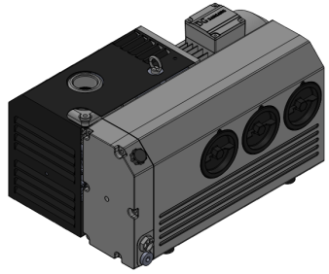

**性能曲線圖 / Performance Curve**

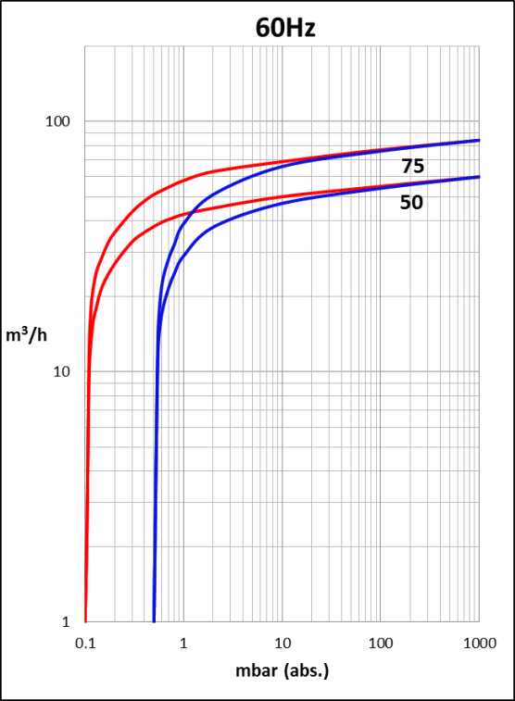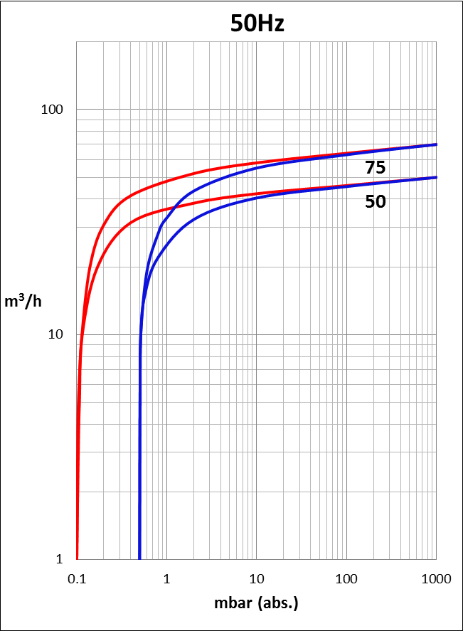

200

200

**―無氣鎮閥without gas ballast**

**―有氣鎮閥 with gas ballast**

|  |  |  |  |  |  |
| --- | --- | --- | --- | --- | --- |
| **VO** | | **50** | | **75** | |
| **頻率Frequency** | Hz | **50Hz** | **60Hz** | **50Hz** | **60Hz** |
| **額定流量Nominal capacity** | m³/h | 50 | 60 | 70 | 84 |
| **絕對真空Ultimate partial pressure** | mbar(abs.) | 0.1 | | | |
| **電機類型Motor version** | 3~ | 50Hz 200-240 / 346-415 V | | | |
| 60Hz 220-275 / 380-480 V | | | |
| **電機功率Motor rating** | kW | 1.25 | 1.5 | 1.85 | 2.2 |
| **電流Current** | A | 5.7 / 3.3 | 5.7 / 3.3 | 7.8 / 4.5 | 8. 2 /4.7 |
| **轉速Speed** | min¯¹ | 1440 | 1720 | 1425 | 1720 |
| **平均噪音值Average noise level** | dB(A) | 64 | 67 | 64 | 68 |
| **最大重量Maximum weight** | kg | 58 | 58 | 58 | 58 |
| **油量Oil capacity** | I | 3.0 | | 3.0 | |

|  |
| --- |
| **VO - 50 / 75油潤滑旋片式真空泵 / Oil Lubricated Rotary Vane Vacuum Pump** |

**尺寸圖 / Dimensions (mm)**



|  |  |  |  |
| --- | --- | --- | --- |
| **A** | **注油口Oil filling point** | **C** | **排油口Oil drain point** |
| **B** | **油位鏡Oil check** | **D** | **油霧分離器Oil separator** |

**我們保留調整數據的權利，尺寸和電流值會因不同的電機而與數據表不同。**

**We reserve the right to alter technical information. The dimensions and the current drawn can differ when compared with the data list, depending on the motor type.**

|  |
| --- |
| **VO - 100 / 150油潤滑旋片式真空泵 / Oil Lubricated Rotary Vane Vacuum Pump** |

Oil lubricated rotary vane vacuum pump with capacities ranging from 100 to 180 m³/h and an ultimate vacuum of 0.1 mbar (abs.).

Flange motor, bearings on both sides of the rotor, air cooling. Fitted as standard with fine mesh filter, vacuum non-return valve, gas ballast valve, protection cover and oil separator.

Flange mounted motors comply with DIN EN 60034, have IP54 protection and insulation class F

油潤滑旋片式真空泵，流量從100至180 m³/hr，絕對真空0.1mbar（絕對值）。法蘭式電機，轉子兩側裝有軸承及空氣冷卻，內置過濾篩網，真空逆止閥，氣鎮閥，保護罩和油氣分離器。葉片採用鋁合金材質，壽命長，汽缸兩側採用O型密封環。

法蘭式電機符合DIN EN60034，具有IP54防護和絕緣等級F

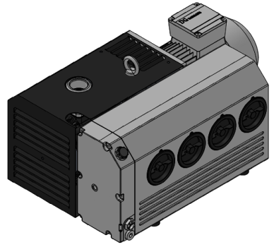

**性能曲線圖 /Performance Curve**

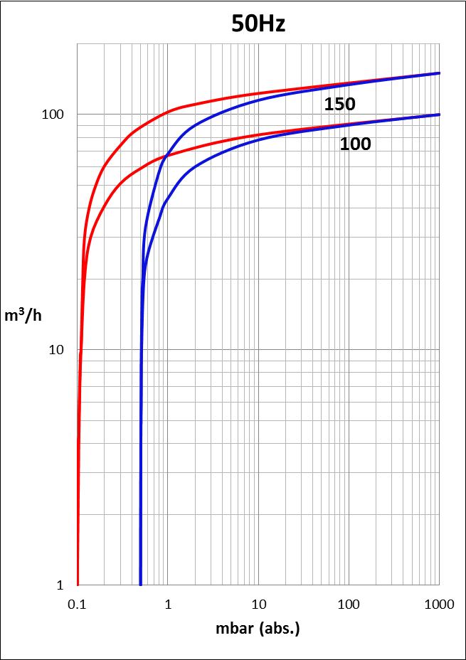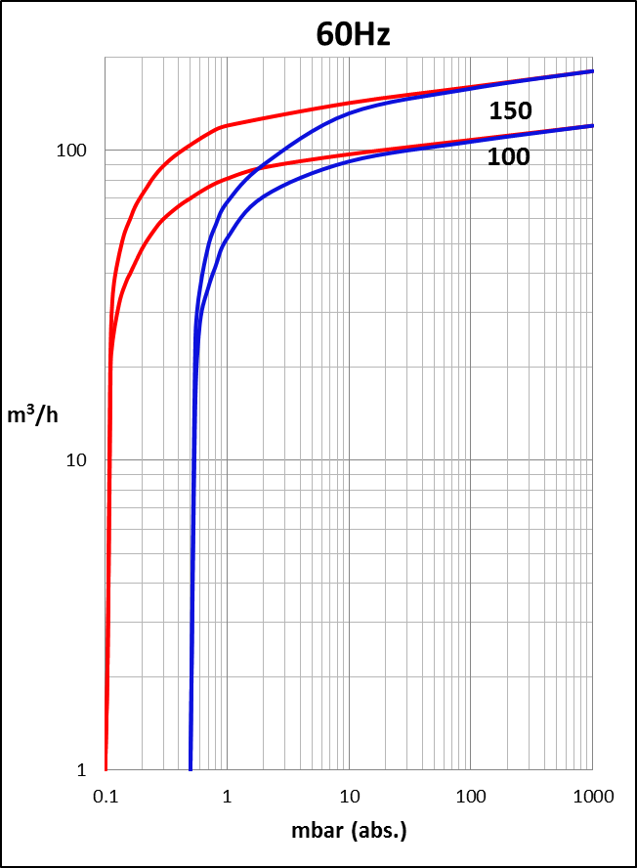

200

200

**―無氣鎮閥without gas ballast**

**―有氣鎮閥 with gas ballast**

|  |  |  |  |  |  |  |
| --- | --- | --- | --- | --- | --- | --- |
| **VO** | | **100** | | | **150** | |
| **頻率Frequency** | Hz | **50Hz** | **60Hz** | | **50Hz** | **60Hz** |
| **額定流量Nominal capacity** | m³/h | 100 | 120 | | 150 | 180 |
| **絕對真空Ultimate partial pressure** | mbar(abs.) | 0.1 | | | | |
| **電機類型Motor version** | 3~ | 50Hz 200-240 / 346-415 V | | | | |
| 60Hz 220-275 / 380-480 V | | | | |
| **電機功率Motor rating** | kW | 2.2 | 2.6 | | 3.0 | 3.7 |
| **電流Current** | A | 9.2 / 5.3 | 9.3 / 5.4 | | 11.8 / 6.80 | 13.0 / 7.50 |
| **轉速Speed** | min¯¹ | 1460 | 1745 | | 1440 | 1720 |
| **平均噪音值Average noise level** | dB(A) | 66 | | 69 | 68 | 71 |
| **最大重量Maximum weight** | kg | 90 | 90 | | 90 | 90 |
| **油量Oil capacity** | I | 3.0 | | | 3.5 | |

|  |
| --- |
| **VO - 100 / 150油潤滑旋片式真空泵 / Oil Lubricated Rotary Vane Vacuum Pump** |

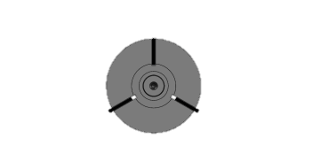

**尺寸圖 / Dimensions (mm)**



**我們保留調整數據的權利，尺寸和電流值會因不同的電機而與數據表不同。**

**We reserve the right to alter technical information. The dimensions and the current drawn can differ when compared with the data list, depending on the motor type.**

|  |  |  |  |
| --- | --- | --- | --- |
| **A** | **注油口Oil filling point** | **C** | **排油口Oil drain point** |
| **B** | **油位鏡Oil check** | **D** | **油霧分離器Oil separator** |

|  |
| --- |
| **VO - 200 / 300油潤滑旋片式真空泵 / Oil Lubricated Rotary Vane Vacuum Pump** |

Oil lubricated rotary vane vacuum pump with capacities ranging from 200 to 360 m³/h and an ultimate vacuum of 0.1 mbar (abs.).

Flange motor, bearings on both sides of the rotor, oil/air heat exchanger. Fitted as standard with fine mesh filter, vacuum non-return valve, gas ballast valve, protection cover and oil separator.

Flange mounted motors comply with DIN EN 60034, have IP54 protection and insulation class F

油潤滑旋片式真空泵，流量從200至360 m³/hr，絕對真空0.1mbar（絕對值）。法蘭式電機，轉子兩側裝有軸承及油／氣熱交換器，內置過濾篩網，真空逆止閥，氣鎮閥，保護罩和油氣分離器。葉片採用鋁合金材質，壽命長，汽缸兩側採用O型密封環。

法蘭式電機符合DIN EN60034，具有IP54防護和絕緣等級F

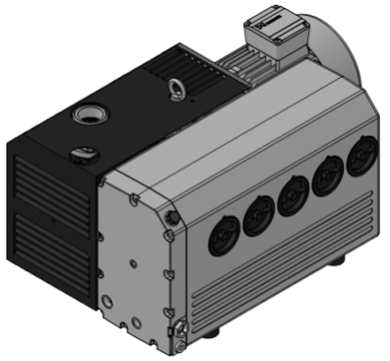

**性能曲線圖 /Performance Curve**

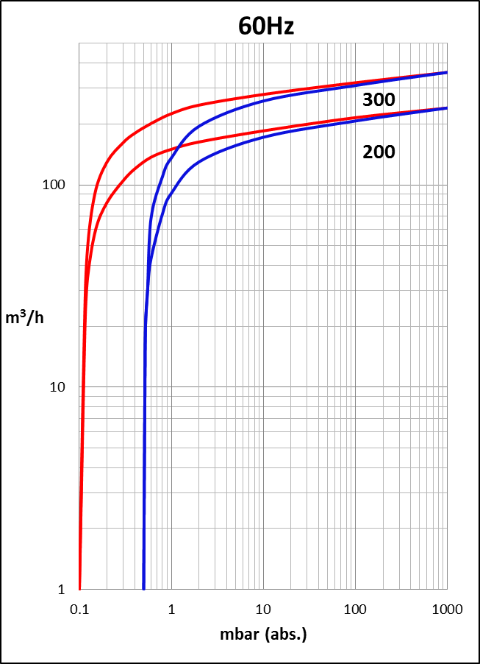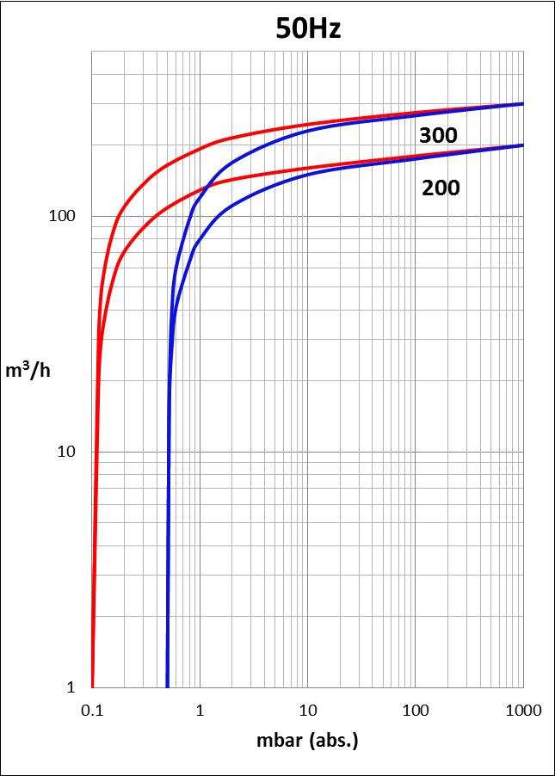

500

500

**―無氣鎮閥without gas ballast**

**―有氣鎮閥 with gas ballast**

|  |  |  |  |  |  |
| --- | --- | --- | --- | --- | --- |
| **VO** | | **200** | | **300** | |
| **頻率Frequency** | Hz | **50Hz** | **60Hz** | **50Hz** | **60Hz** |
| **額定流量Nominal capacity** | m³/h | 200 | 240 | 300 | 360 |
| **絕對真空Ultimate partial pressure** | mbar(abs.) | 0.1 | | | |
| **電機類型Motor version** | 3~ | 50Hz 200-240 / 346-415 V | | | |
| 60Hz 220-275 / 380-480 V | | | |
| **電機功率Motor rating** | kW | 5.5 | 6.3 | 7.5 | 8.6 |
| **電流Current** | A | 20.5 / 11.9 | 21.4 /12.3 | 28.3 / 16.4 | 29.0 /16.8 |
| **轉速Speed** | min¯¹ | 1470 | 1760 | 1470 | 1760 |
| **平均噪音值Average noise level** | dB(A) | 69 | 73 | 70 | 74 |
| **最大重量Maximum weight** | kg | 179 | 179 | 182 | 182 |
| **油量Oil capacity** | I | 8 | | 8 | |

**―無氣鎮閥without gas ballast**

**―有氣鎮閥 with gas ballast**

|  |
| --- |
| **VO - 200 / 300油潤滑旋片式真空泵 / Oil Lubricated Rotary Vane Vacuum Pump** |

**尺寸圖 / Dimensions (mm)**



|  |  |  |  |
| --- | --- | --- | --- |
| **A** | **注油口Oil filling point** | **C** | **排油口Oil drain point** |
| **B** | **油位鏡Oil check** | **D** | **油霧分離器Oil separator** |

**我們保留調整數據的權利，尺寸和電流值會因不同的電機而與數據表不同。**

**We reserve the right to alter technical information. The dimensions and the current drawn can differ when compared with the data list, depending on the motor type.**

**配件 /** Accessories



**入口過濾器 / Suction filter**

|  |  |  |  |  |  |  |  |  |
| --- | --- | --- | --- | --- | --- | --- | --- | --- |
| 型號/Type | m³/h | R | A | B | C | D | 重量KG | 材質( material ) / 精度( accuracy) |
| VF-06 | 45 | G 3/4" | 102 | 95 | 57 | 51 | 0.6 | 紙濾心(Paper filter) / 20um |
| VF-10 | 100 | G 1 1/4" | 146 | 116 | 82 | 70 | 1.4 | 紙濾心(Paper filter) / 20um |
| VF-12 | 200 | G 1 1/2" | 190 | 195 | 110 | 109 | 2.3 | 紙濾心(Paper filter) / 20um |
| VF-16 | 360 | G 2" | 220 | 265 | 118 | 130 | 4.5 | 紙濾心(Paper filter) / 20um |
| VF-20 | 360 | G 2 1/2" | 220 | 265 | 118 | 130 | 4.5 | 紙濾心(Paper filter) / 20um |

**VF Series尺寸圖 / Dimensions (mm)**



**油霧過濾器** **/** **Oil separator**



|  |  |  |
| --- | --- | --- |
| 型號 / Type | A | 適用機型/ Applicable models |
| VO- 20-018 | 128 (Fig.1) | VO-20 |
| VO-150-018 | 102 (Fig.2) | VO-50,75,100,150 |
| VO-300-018 | 152 (Fig.2) | VO-200,300 |



**配件 /** Accessories

**逆止閥 / Non-return valve**



**尺寸圖 / Dimensions (mm)**

|  |  |  |  |
| --- | --- | --- | --- |
| 型號 / Type | A | B | C |
| NRV-03 | 88 | 105 | G 1 1/4" |
| NRV-04 | 88 | 105 | G 1 1/2" |
| NRV-05 | 116 | 130 | G 2" |

**防震腳墊 / Footprint dimensions [mm]**

|  |  |  |  |  |
| --- | --- | --- | --- | --- |
| 型號 Type | D | H | G | L |
| MFB2520 | 25 | 20 | M6 | 12 |
| MFB3025 | 30 | 25 | M8 | 15 |
| MFB5020 | 50 | 20 | M10 | 20 |
| MFB7545 | 75 | 40 | M12 | 20 |

